T-2HAND

Software Development Plan

(Small Project)

Version <1.1>

Revision History

| **Date** | **Version** | **Description** | **Author** |
| --- | --- | --- | --- |
| 03/11/2024 | 1.0 | Basic plan for the product | Trần Đan Huy |
| 14/11/2024 | 1.1 | Additional Project Planning and Estimating | Lâm Sỹ Tân |
|  |  |  |  |
|  |  |  |  |

Table of Contents

**● 4**

**1. Introduction 4**

*1.1 Purpose 4*

*1.2 Scope 4*

*1.3 Overview 4*

**2. Project Overview 4**

*2.1 Project Purpose, Scope, and Objectives 4*

*2.2 Assumptions and Constraints 4*

2.2.1 Assumptions 4

2.2.2 Constraints 5

*2.3 Project Deliverables 5*

**3. Project Organization 6**

*3.1 Organizational Structure 6*

*3.2 Roles and Responsibilities 7*

**4. Management Process 8**

*4.1 Project Estimates 8*

4.1.1 Sprint Estimation 8

4.1.2 Cost Estimation 8

4.1.3 Task and Feature Estimation 8

*4.2 Project Plan 12*

4.2.1 Phase Plan 12

4.2.2 Releases 13

4. 2.3 Iteration Plan 14

*4.3 Project Monitoring and Control 21*

4.3.1 Reporting 21

4.3.2 Configuration Management 22

Software Development Plan (Small Project)

# Introduction

## Purpose

This Software Development Plan document provides an overview of the entire software development process, including project objectives, scope, and the steps required to complete the project. The document details technical requirements, development approach, and implementation roadmap to ensure the quality and efficiency of the software. This plan serves as a guiding foundation for the development team and as a basis to ensure that the final product meets user needs and adheres to the specified technical standards.

The following people use the Software Development Plan:

* The project manager uses it to plan the project schedule and resource needs, and to track progress against the schedule.
* Project team members use it to understand what they need to do, when they need to do it, and what other activities they are dependent upon

## Scope

This Software Development Plan describes the overall plan to be used by the T-2hand project including deployment of the product. The details of the individual interactions will be described in the Iteration Plans.

The plans as outlined in this document are based upon the product requirements as defined in the Vision Document

## Overview

This Software Development Plan contains the following information:

* Project Overview - provides a description of the project’s purpose, scope and objectives. It also defines the deliverables that the project is expected to deliver.
* Project Organization – describes the organizational structure of the project team.

# Project Overview

## Project Purpose, Scope, and Objectives

The T-2Hand project builds a web platform that enables users to buy and sell second-hand items, helping to reduce waste and save costs while creating a safe and convenient trading environment. The goal is to support sustainable consumption by encouraging product reuse, making it easy for sellers to list items and for buyers to find suitable options.

The T-2Hand project will deliver a complete web application that allows users to register and log in according to their roles (Admin, Seller, Buyer). The user management system will include account registration, role assignment, and profile management. The online marketplace platform will provide features for sellers to list products, manage their listings, and directly message buyers, as well as enable buyers to search for, filter products, add items to their cart, and proceed to checkout. The Admin dashboard will assist in monitoring user accounts, approving listings, and handling complaints. Additionally, the system will provide real-time notifications about transactions and include a detailed transaction statistics table for Admins to track transactions.

## Assumptions and Constraints

### Assumptions

* **User Needs:** Users require an easy-to-use platform for buying and selling second-hand items while saving costs, and they also wish for a convenient platform to facilitate these transactions.
* **Technology:** The project will utilize modern web technologies, including React.js for the user interface and Express.js for the backend, with the assumption that team members possess the necessary skills and experience to work with these technologies.
* **User Base:** It is expected that there will be sufficient users aged 18 and older participating on the platform, including both sellers and buyers.
* **Data Privacy:** Users trust the platform to protect their personal information.
* **Feature Requirements:** The core features of the platform, such as account registration, product management, direct messaging between buyers and sellers, and a complaint management system, will be developed and function smoothly as planned, without significant changes in user requirements.

### Constraints

* **Project Timeline:** The project is expected to be completed within a fixed timeframe of 12 weeks, including the development, testing, and deployment phases.
* **Budget Limitations:** The project operates on a limited budget, restricting costs for resources or additional features that may arise during development.
* **Regulatory Compliance:** The project must comply with data privacy regulations and e-commerce laws to ensure user trust and legal compliance, which may restrict some features or data handling methods.
* **Scope:** The project scope will be limited to building essential functions to meet the basic requirements for the product launch. Additional features will not be included in the initial plan but will be considered for development in future updates after the product has been released.
* **Quality Assurance:** All functions must pass thorough testing phases, including unit testing, integration testing, and user acceptance testing before deployment.
* **Technical Limitations:** The project relies on specific technologies (React.js and Express.js), which may impose limits on the features and functionalities that can be implemented if team members face challenges with these technologies.

## Project Deliverables

* Software Development Plan
* Software Architecture Document
* Vision Document
* User Interface Design
* Testing Report: Test reports include unit reports and overall reports
* Web Application Source Code
* Analysis and Design Document
* Use Case Diagrams
* Use Case Specifications
* Design Model
* Implementation Subsystem
* Software Requirements Specification
* Change Request

# Project Organization

## Organizational Structure

## Roles and Responsibilities

| **Person** | **Role** |
| --- | --- |
| **Lâm Sỹ Tân**  **(Leader)** | * **Project Manager:** Manages the entire project. * **Business Process Analyst:** Analyzes business processes. * **Requirements Specifier:** Specifies software requirements. * **System Test Designer:** Designs system test cases. * **System Tester:** Executes integration and system tests. * **UI Designer:** Designs the user interface. * **Developer:** Codes the software. * **Unit Test Analyst:** Analyzes and executes unit tests. * **Unit Tester:** Executes software unit tests. |
| **Ôn Gia Bảo** | * **System Engineering Leader:** Leads the systems engineering team. * **System Integrator:** Integrates systems and components. * **System Test Designer:** Designs system test cases. * **System Test Analyst:** Analyzes and executes system tests. * **System Tester:** Executes integration and system tests. * **UI Designer:** Designs the user interface. * **Developer:** Codes the software. * **Unit Test Analyst:** Analyzes and executes unit tests. * **Unit Tester:** Executes software unit tests |
| **Võ Hoàng Đức** | * **Systems Analyst:** Analyzes systems and requirements. * **System Integrator:** Integrates systems and components. * **System Tester:** Executes integration and system tests. * **Software Engineering Leader:** Leads the software development team. * **Software Architect:** Designs the software architecture. * **Developer:** Codes the software. * **Unit Test Designer:** Designs unit test cases. * **Unit Test Analyst:** Analyzes and executes unit tests. * **Unit Tester:** Executes software unit tests |
| **Trần Đan Huy** | * **Business Modelling Leader:** Leads the business modeling team. * **Business Designer:** Designs business solutions. * **Requirements Specifier:** Specifies software requirements. * **Systems Analyst:** Analyzes systems and requirements. * **System Test Manager:** Manages integration and system testing. * **System Test Analyst:** Analyzes and executes system tests. * **System Tester:** Executes integration and system tests. * **Developer:** Codes the software. * **Unit Test Analyst:** Analyzes and executes unit tests. * **Unit Tester:** Executes software unit tests |
| **Trần Thị Cát Tường** | * **Business Process Analyst:** Analyzes business processes. * **Requirements Specifier:** Specifies software requirements. * **System Tester:** Executes integration and system tests. * **Software Architect:** Designs the software architecture. * **UI Designer:** Designs the user interface. * **Developer:** Codes the software. * **Unit Test Manager:** Manages unit testing. * **Unit Test Analyst:** Analyzes and executes unit tests. * **Unit Tester:** Executes software unit tests |

# Management Process

## Project Estimates

### 4.1.1 Sprint Estimation

*Here’s a detailed overview of the key objectives and focus areas for each sprint.*

Sprint 0 (Proposal): Come up with ideas and define the objects and functions of the project (1 weeks).

Sprint 1: Basic document and define the project (2 weeks).

Sprint 2: Document training and Specifying use case (1 weeks).

Sprint 3: Software architecture, detail Specifications use case, class diagram and document training (1 weeks).

Sprint 4: Software architecture, UI prototype, Front End Implementation and Back End Implementation

Sprint 5: Front End Implementation and Back End Implementation, test cases, test plan and full-stack development (2 weeks).

Sprint 6: Fix bugs and finalizing the product and preparation for presentation (2 weeks).

### 4.1.2 Cost Estimation

* The project is estimated to run for a total of **9 weeks**, finishing at the end of the Introduction to Software Engineering course
* Estimating each day, each member uses **5 hours** on the project, so in **9 weeks**, which is about **63 days**. Therefore, the estimated working time would be about **315 hours** in total for each person

### 4.1.3 Task and Feature Estimation

#### *4.1.3.1 Feature Estimation*

For feature estimation, we estimate the analyzing and designing time about 0.5 days** per feature, for difficult features maybe we have to double this number to 1 day. In addition, we need 1-2 days to finish developing each feature

and if the features which are quite similar to these we have done previously, the figure can be down to 0.5 days. Finally for documentation, we just need 0.5 days to research each for each feature.

**\*\*1 day = 3 hours**

| **No** | **Feature** | **Analyzing and Designing Time** | **Developing Time** | **Documentation Time** | **Total Estimated Time** |
| --- | --- | --- | --- | --- | --- |
| **Admin: The features of Admin role** | | | | | |
| 1 | Sign up, sign in, sign out | 0.5 day | 2 days | 0..5 day | 3 days |
| 2 | Approving and managing | 0.5 day | 1 days | 0.5 day | 2 days |
| 3 | Product approval | 0.5 day | 1 days | 0.5 day | 2 days |
| 4 | Managing reported products | 0.5 day | 1 days | 0.5 day | 2 days |
| 5 | Support request management | 0.5 day | 1 days | 0.5 day | 2 days |
| 6 | Complaint management | 0.5 day | 1 days | 0.5 day | 2 days |
| 7 | View total number of current users | 0.5 day | 0.5 days | 0.5 day | 1.5 days |
| 8 | Create a transaction statistics table | 0.5 day | 0.5 days | 0.5 day | 1.5 days |
| **Seller: The feature of Seller role** | | | | | |
| 1 | Sign up, sign in, sign out. | 0.5 day | 0.5 day | 0.5 day | 1.5 days |
| 2 | Choose role | 0.5 day | 1 day | 0.5 day | 2 days |
| 3 | Display seller’s page | 1 day | 2 days | 0.5 day | 3.5 days |
| 4 | Chatting | 0.5 day | 2 days | 0.5 day | 3 days |
| 5 | Upload Items | 0.5 day | 1 day | 0.5 day | 2 days |
| 6 | Manage Listings | 0.5 day | 1 day | 0.5 day | 2 days |
| 7 | Review History | 0.5 day | 1 day | 0.5 day | 2 days |
| 8 | Real-time notification | 0.5 day | 1 day | 0.5 day | 2 days |
| 9 | Contact with admins | 0.5 day | 1 day | 0.5 day | 2 days |
| **Customer: The features of Customer role** | | | | | |
| 1 | Sign up, sign in, sign out. | 0.5 day | 0.5 day | 0.5 day | 1.5 days |
| 2 | Choose role | 0.5 day | 0.5 day | 0.5 day | 1.5 days |
| 3 | Displays customer’s profile | 0.5 day | 0.5 day | 0.5 day | 1.5 days |
| 4 | Search & Filter Options | 1 day | 1 day | 0.5 day | 2.5 days |
| 5 | Browse Items | 0.5 day | 0.5 day | 0.5 day | 1.5 days |
| 6 | Shopping Cart | 0.5 day | 0.5 day | 0.5 day | 1.5 days |
| 7 | Place Order | 0.5 day | 0.5 day | 0.5 day | 1.5 days |
| 8 | Chatting | 0.5 day | 0.5 day | 0.5 day | 1.5 days |
| 9 | Leave Feedback & Rate Seller | 1 day | 1 day | 0.5 day | 2.5 days |
| 10 | Report items | 0.5 day | 0.5 day | 0.5 day | 1.5 days |
| 11 | Real-time notification | 0.5 day | 0.5 day | 0.5 day | 1.5 days |

Moreover, perhaps some features can be executed parallel, so the total time estimate of features will decrease if we all work smoothly. Additionally, these estimations above are just to predict time to finish each feature, we can rely on them and divide tasks for team members to perform efficiently as soon as possible.

#### *4.1.3.2 Task Estimation*

Beside developing features, we also estimate time for tasks related to documents to ensure our project works properly, our plan matches with the real strategies of software development.

**\*\*1 day = 3 hours**

| **No** | **Task name** | **Researching Time** | **Executing Time** | **Total Estimated Time** |
| --- | --- | --- | --- | --- |
| 1 | Project Proposal | 12 days | 1 day | 13 days |
| 2 | Project Plan | 12 days | 1 day | 13 days |
| 3 | Vision Document | 12 days | 1 day | 13 days |
| 4 | Design basic UI on  figma | 2 days | 12 days | 14 days |
| 5 | Revised Project Plan | 1 day | 1 day | 2 days |
| 6 | Revised Vision Document | 1 day | 1 day | 2 days |
| 7 | Use-case model | 5 days | 1 day | 6 days |
| 8 | Use-case specification | 5 days | 1 day | 6 days |
| 9 | Revised Use-case specification | 1 day | 1 day | 2 days |
| 10 | Define Software Architecture | 5 days | 1 day | 6 days |
| 11 | Class diagram | 5 days | 1 day | 6 days |
| 12 | Revised Software Architecture Document | 1 day | 1 day | 2 days |
| 13 | UI Prototype | 5 days | 1 day | 6 days |
| 14 | Test Plan | 12 days | 1 day | 13 days |
| 15 | Test Case | 12 days | 1 day | 13 days |
| 16 | Prepare Presentation | 10 days | 2 days | 12 days |
| 17 | Weekly Reports | 3 days | 21 days | 24 days |

## Project Plan

### Phase Plan

*The phases and the relative timeline are shown in the table below.*

| **Phase** | **Sprints** | **Start date** | **Finish date** |
| --- | --- | --- | --- |
| **Inception** | 2 | 10/10/2024 | 6/11/2024 |
| **Elaboration** | 2 | 7/11/2024 | 20/11/2024 |
| **Construction** | 3 | 21/11/2024 | 25/12/2024 |

*The Work Breakdown Structure for this project is shown in the image below*

* **WBS:**

*We also include a gantt chart to illustrate the timeline of each sprints in each phases*

* **Gantt chart:**

### Releases

The Software Development Plan is centered on the initial two releases of the T-2HAND website. These early versions will include key features highlighted in the Vision Document. The first release (version 1.0) will focus on delivering essential functionalities for user event promotion.

As the project evolves, adjustments to the release content may be necessary due to technical challenges. We will evaluate product requirements by considering factors such as benefit, effort, and risk to determine the composition of each release.

| **Version** | **Date** | **Functions** |
| --- | --- | --- |
| 1.0 | 11/12/2024 | **Admin**   * Sign up, sign in, sign out * Approving and managing * Product approval * Managing reported products * Support request management * Complaint management * View total number of current users * Create a transaction statistics table   **Seller**   * Sign up, sign in, sign out. * Choose role * Display seller’s page * Chatting * Upload Items * Manage Listings * Review History * Real-time notification * Contact with admins   **Customer**   * Sign up, sign in, sign out. * Choose role * Displays customer’s profile * Search & Filter Options * Browse Items * Shopping Cart * Place Order * Leave Feedback & Rate Sellers * Report items * Real-time notification |
| 1.1 | 25/12/2024 | All these functions above, but we will have optimized them to illustrate them well, ensure work smoothly and reduce errors. |

### 4. 2.3 Iteration Plan

#### *4.2.3.1 Inception Phase*

1. Sprint 0

* Duration: 14 days (10/10/2024 - 23/10/2024)
* Schedule:

| No | Task name | Label | Assignment | Start date | End date |
| --- | --- | --- | --- | --- | --- |
| 1 | Project Proposal | Docx | All members | 10/10/2024 | 22/10/2024 |
| 1.1 | Introduction | Docx | Lâm Sỹ Tân | 10/10/2024 | 12/10/2024 |
| 1.2 | Target users | Docx | Lâm Sỹ Tân  Trần Thị Cát Tường | 13/10/2024 | 15/10/2024 |
| 1.3 | Environments |  | Ôn Gia Bảo  Võ Hoàng Đức | 10/10/2024 | 16/10/2024 |
| 1.4 | Key features | Docx | Lâm Sỹ Tân  Trần Thị Cát Tường  Trần Đan Huy | 15/10/2024 | 21/10/2024 |
| 2 | Weekly report | Docx | Trần Thị Cát Tường | 21/10/2024 | 22/10/2024 |
| 3 | Assignment PA0 | PA | Lâm Sỹ Tân | 22/10/2024 | 23/10/2024 |

* Deliverables: The products of Sprint 0 are Project Proposal, which is the initial document about the general base of T-2HAND web app, and Weekly Report.
* Gantt Chart:

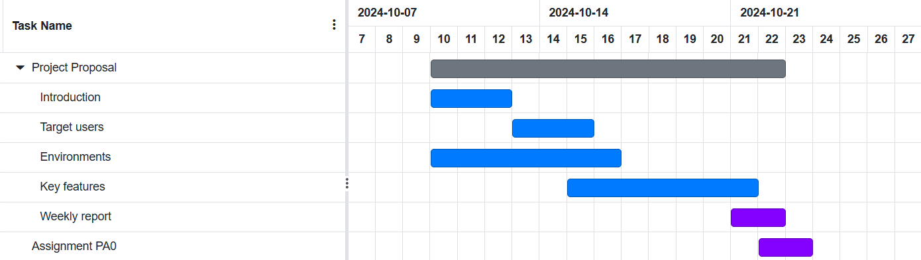

1. Sprint 1

* Duration: 14 days (24/10/2024 - 06/11/2024)
* Schedule:

| No | Task name | Label | Assignment | Start date | End date |
| --- | --- | --- | --- | --- | --- |
| 1 | Project Plan | Docx | Trần Đan Huy  Ôn Gia Bảo  Lâm Sỹ Tân  Võ Hoàng Đức | 24/10/2024 | 04/11/2024 |
| 1.1 | Introduction | Docx | Trần Đan Huy | 24/10/2024 | 04/11/2024 |
| 1.2 | Project OverView | Docx | Trần Đan Huy | 24/10/2024 | 04/11/2024 |
| 1.3 | Project Organization | Docx | Ôn Gia Bảo | 24/10/2024 | 04/11/2024 |
| 1.4 | Project Estimation | Docx | Lâm Sỹ Tân | 24/10/2024 | 04/11/2024 |
| 1.5 | Project Plan | Docx | Lâm Sỹ Tân | 24/10/2024 | 04/11/2024 |
| 1.6 | Project Monitoring and Control | Docx | Võ Hoàng Đức | 24/10/2024 | 04/11/2024 |
| 2 | Vision Document | Docx | All members | 24/10/2024 | 04/11/2024 |
| 2.1 | Introduction | Docx | Lâm Sỹ Tân | 24/10/2024 | 04/11/2024 |
| 2.2 | Positioning | Docx | Trần Thị Cát Tường | 24/10/2024 | 04/11/2024 |
| 2.3 | User Descriptions | Docx | Trần Đan Huy | 24/10/2024 | 04/11/2024 |
| 2.4 | Product Features | Docx | Võ Hoàng Đức | 24/10/2024 | 04/11/2024 |
| 2.5 | Non-Functional Requirements | Docx | Ôn Gia Bảo | 24/10/2024 | 04/11/2024 |
| 2.6 | Weekly Report | Docx | Trần Đan Huy | 24/10/2024 | 04/11/2024 |
| 2.7 | Assignment PA1 | Docx | Lâm Sỹ Tân | 05/11/2024 | 06/11/2024 |
| 3 | Design basic web on figma | Des | Trần Thị Cát Tường  Lâm Sỹ Tân  Ôn Gia Bảo | 24/10/2024 | 06/11/2024 |
| 4 | Learning | Code | Võ Hoàng Đức  Trần Thị Cát Tường | 24/10/2024 | 06/11/2024 |

* Deliverables: The products of Sprint 1 are Project Plan, Vision Document and basic web design on figma, and Weekly Report.
* Gantt Chart:

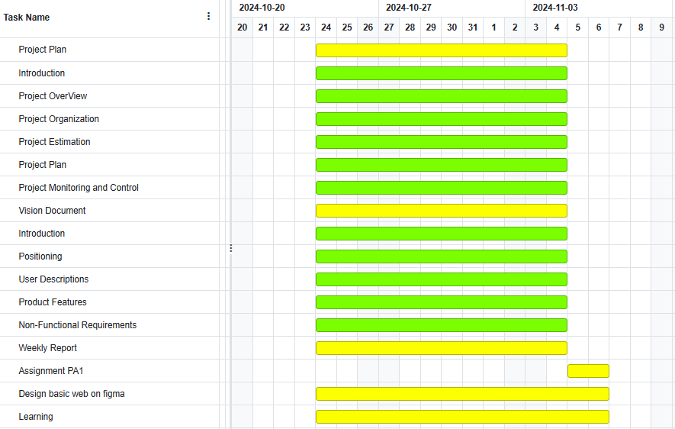

#### *4.2.3.2 Elaboration Phase*

1. Sprint 2

* Duration: 7 days (07/11/2024 - 13/11/2024)
* Schedule:

| No | Task name | Label | Assignment | Start date | End date |
| --- | --- | --- | --- | --- | --- |
| 1 | Revised Project Plan | Docx | All members | 07/11/2024 | 12/11/2024 |
| 2 | Revised Vision Document | Docx | Lâm Sỹ Tân | 07/11/2024 | 12/11/2024 |
| 3 | Use-case model | Docx | Ôn Gia Bảo | 07/11/2024 | 12/11/2024 |
| 4 | Use-case specification | Docx | Trần Thị Cát Tường  Võ Hoàng Đức | 07/11/2024 | 12/11/2024 |
| 4.1 | Use-case specification focus on name, basic flow, alternative flows | Docx | Trần Thị Cát Tường | 07/11/2024 | 12/11/2024 |
| 4.2 | Use-case specification focus on pre-conditions, and post-conditions | Docx | Võ Hoàng Đức | 07/11/2024 | 12/11/2024 |
| 5 | Weekly report | Docx | Trần Đan Huy | 07/11/2024 | 12/11/2024 |
| 6 | Assignment PA2 | PA | Lâm Sỹ Tân | 12/11/2024 | 13/11/2024 |
| 7 | Learning | Code | All members | 07/11/2024 | 13/11/2024 |

* Deliverables: The products of Sprint 2 are revised version of the Project Plan, Vision Document and also Use-case model, Use-case specification, and Weekly Report
* Gantt Chart:

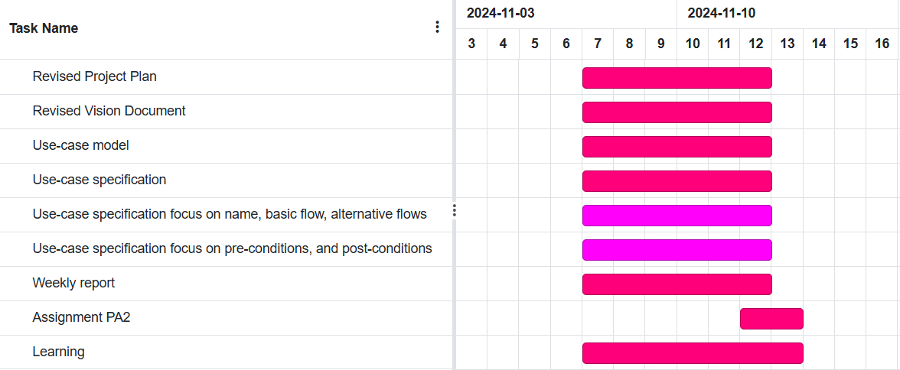

1. Sprint 3

* Duration: 7 days (14/11/2024 - 20/11/2024)
* Schedule:

| No | Task name | Label | Assignment | Start date | End date |
| --- | --- | --- | --- | --- | --- |
| 1 | Revised Use-case specification | Docx | Trần Thị Cát Tường | 14/11/2024 | 19/11/2024 |
| 2 | Define Software Architecture | Docx | Lâm Sỹ Tân | 14/11/2024 | 19/11/2024 |
| 2.1 | Divide the system into components, connect, describe each component in detail in the Logical View section of the SAD document | Docx | Lâm Sỹ Tân  Trần Thị Cát Tường | 14/11/2024 | 19/11/2024 |
| 2.2 | Describe responsibility and how component is connected with other  components in Section 4.x | Docx | Võ Hoàng Đức | 14/11/2024 | 19/11/2024 |
| 3 | Class diagram | Docx | Ôn Gia Bảo  Trần Đan Huy | 14/11/2024 | 19/11/2024 |
| 4 | Weekly report | Docx | Trần Đan Huy | 14/11/2024 | 19/11/2024 |
| 5 | Assignment PA3 | PA | Lâm Sỹ Tân | 19/11/2024 | 20/11/2024 |

* Deliverables: The products of Sprint 3 are revised of the Use-case model, Use-case specification, a detailed brief of Software architecture, Class Diagram and Weekly Report.
* Gantt Chart:

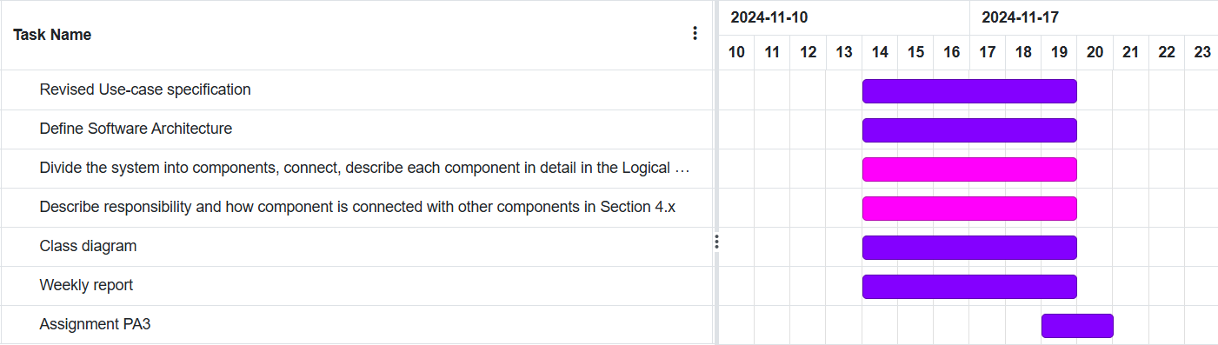

#### *4.2.3.3 Construction Phase*

1. Sprint 4

* Duration: 7 days (21/11/2024 - 27/11/2024)
* Schedule:

| No | Task name | Label | Assignment | Start date | End date |
| --- | --- | --- | --- | --- | --- |
| 1 | Revised Software Architecture Document | Docx | Trần Thị Cát Tường  Võ Hoàng Đức | 21/11/2024 | 26/11/2024 |
| 2 | UI Prototype | Docx | Trần Thị Cát Tường  Trần Đan Huy | 21/11/2024 | 26/11/2024 |
| 3 | Front End Implementation | Docx | Trần Thị Cát Tường  Võ Hoàng Đức | 21/11/2024 | 26/11/2024 |
| 4 | Back End Implementation | Code | Ôn Gia Bảo  Võ Hoàng Đức  Lâm Sỹ Tân  Trần Đan Huy | 21/11/2024 | 26/11/2024 |
| 5 | Weekly report | Docx | Trần Đan Huy | 21/11/2024 | 26/11/2024 |
| 6 | Assignment PA4 | PA | Lâm Sỹ Tân | 26/11/2024 | 27/11/2024 |
| 7 | Learning | Info | All members | 21/11/2024 | 27/11/2024 |
| 8 | Training | Train | All members | 21/11/2024 | 27/11/2024 |

* Deliverables: The products of Sprint 4 are revised from the Software architecture document, a brief of UI Prototype, and Weekly Report.
* Gantt Chart:

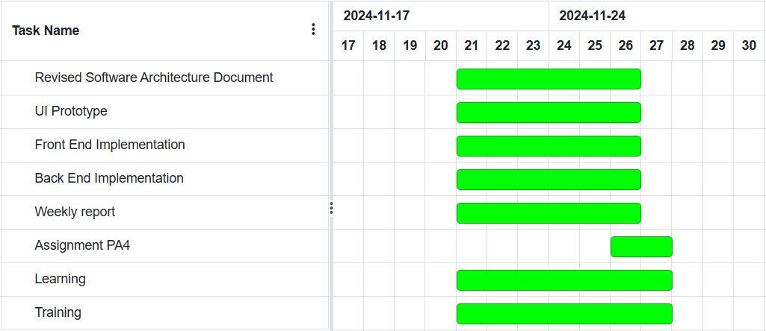

1. Sprint 5

* Duration: 14 days (28/11/2024 - 11/12/2024)
* Schedule:

| No | Task name | Label | Assignment | Start date | End date |
| --- | --- | --- | --- | --- | --- |
| 1 | Test Case and Test Plan | Docx | All members | 28/11/2024 | 10/12/2024 |
| 1.1 | Test Plan | Docx | Lâm Sỹ Tân  Trần Thị Cát Tường | 28/11/2024 | 10/12/2024 |
| 1.2 | Design Test Case | Docx | Võ Hoàng Đức  Ôn Gia Bảo | 28/11/2024 | 10/12/2024 |
| 1.3 | Execute Test Case | Docx | Trần Đan Huy | 28/11/2024 | 10/12/2024 |
| 1.4 | Test Report | Docx | Trần Đan Huy | 28/11/2024 | 10/12/2024 |
| 2 | Front End Implementation | Code | Trần Thị Cát Tường  Võ Hoàng Đức | 28/11/2024 | 11/12/2024 |
| 3 | Back End Implementation | Code | Ôn Gia Bảo  Võ Hoàng Đức  Lâm Sỹ Tân  Trần Đan Huy | 28/11/2024 | 11/12/2024 |
| 4 | Weekly Report |  | Trần Đan Huy | 28/11/2024 | 10/12/2024 |
| 5 | Assignment PA5 | PA | Lâm Sỹ Tân | 10/11/2024 | 11/12/2024 |
| 6 | Training | Train | All members | 28/11/2024 | 11/12/2024 |
| 7 | Learning | Info | All members | 28/11/2024 | 11/12/2024 |

* Deliverables: The products of Sprint 5 are Test Case, Test Plan, Test report, and Weekly Report.
* Gantt Chart:

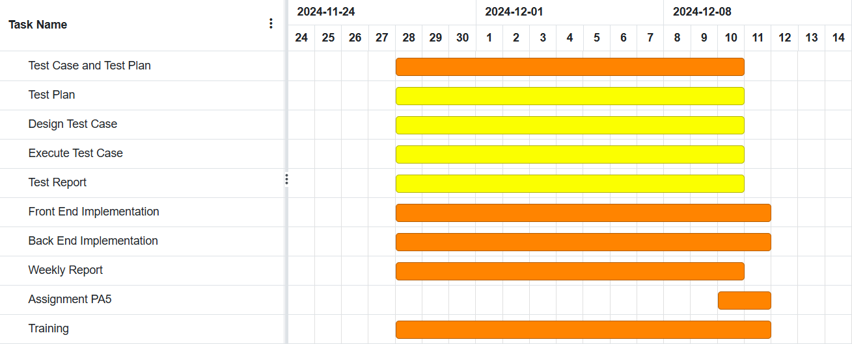

1. Sprint 6

* Duration: 14 days (12/12/2024 - 25/12/2024)
* Schedule:

| No | Task name | Label | Assignment | Start date | End date |
| --- | --- | --- | --- | --- | --- |
| 1 | Fix bugs | Docx | All members | 12/12/2024 | 24/12/2024 |
| 2 | Prepare Presentation | Docx | All members | 12/12/2024 | 24/12/2024 |
| 3 | Weekly report | Docx | Trần Đan Huy | 12/12/2024 | 24/12/2024 |
| 4 | Assignment PA6 | PA | Lâm Sỹ Tân | 24/12/2024 | 25/10/2024 |

* Deliverables: The products of Sprint 6 are the presentation for our web app, the final submission, and Weekly Report.
* Gantt Chart:

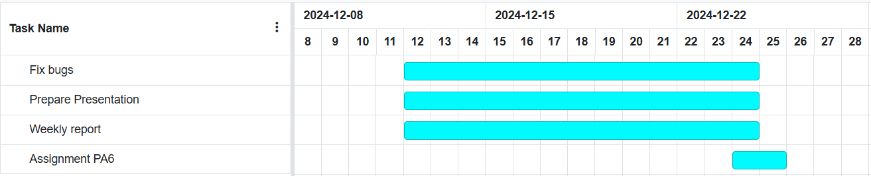

## Project Monitoring and Control

### Reporting

The project status will be reported weekly through:

* Weekly meeting report: including the revision of the last work, the discussion of the meeting, and incoming tasks.
* Weekly status report: show the progress of the project.
* Weekly planning report: plan with detailed work and deadlines for each team member.

### Configuration Management

* The reports, comments in written form, sharing documents, and text files are stored in Google Drive in each folder corresponding to each stage of the project.
* Jira for assigning work and tracking the work of each team member.
* Source code for the project and related files are managed in GitHub.